Dear Parents:
[District Name] is partnering with First Student to launch First View®, a secure, easy-to-use
app that keeps you connected to your student’s trip progress in real time.
What You Can Do with First View
- See real-time vehicle location via GPS and track its progress
- Easily access vehicle details and updates regarding any changes
- Receive distance notification and automated arrival alerts when the vehicle is close
- Set-up family members and caregivers to receive trip email alerts
- Connect with a dedicated support team for your all app-related needs

How to Get Started with First View
1. Download the free, easy-to-use mobile app, which is available on both iOS and Android devices. Search for app name First View or visit myfirstview.com and create an account.
Not all devices are compatible and must meet the minimum
operating system requirements. Make sure to allow notifications
and enable location-based services for notification set-up.
2. Create your student’s profile by clicking on the + sign on the map.
You’ll be asked to enter:
 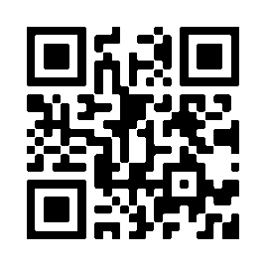Scan the QR Code to
download First View
- The 5-character district code: [XXXXX]
- Your student’s ID and last name

3. You will be connected automatically to your student’s trip information. You can view the schedule under Students in the app menu or view today’s trips on the Map home screen.

4. Set-up distance notifications to be alerted in the app or push notification when the trip is live. Click on Set Notifications on the map or in Notification Settings to add up to 3 notification zones per trip. Customize the notification pinpoint, distance range, and time range for accurate and timely alerts as the vehicle is approaching your student’s stop.

Want to get email alerts? Add yourself and up to 10 family members or caregivers as a notification recipient. To set this up in the app, click on the notification bell and select Manage Recipients.

5. Once you have finished setting up your profile, click on the map to begin tracking or view your student details, add another student profile, or view account information and settings in the menu.

Need assistance? Tap Contact Support in the app (Mon–Fri, 7 AM–5 PM ET) for app-related questions or concerns.

If you have questions about your student’s assigned trip or stop information, please contact [District or School Contact Information].

