FirstView will be relaunching the One Stop Shop in SY22/23 with updated logos, training documents, and marketing materials. You can find additional information in First Student’s brand guidelines.

To access our existing materials, please use the links below:

FirstView GPS Toolkit - https://bit.ly/FirstView_GPS
FirstView Stop Toolkit - https://bit.ly/FirstView_Toolkit

If you are unsure of which toolkit to use for your district, please contact implementation@firstviewapp.com

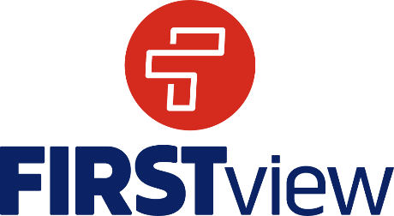
New Logo & Colors

District Dashboard is now DistrictView
Parent App is now ParentView

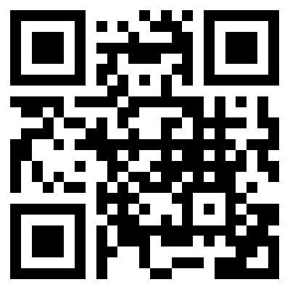
QR Code linking to https://firstviewapp.com
Right-click to Save Picture or click on the links to view new logos.

