Date

Dear Parents:

In collaboration with our transportation partner, First Student, [District Name] is launching FirstView®, a real-time GPS vehicle tracking and student transportation monitoring platform.

With FirstView, parents and caregivers can download the secure, easy-to-use vehicle tracking mobile app that will allow you to stay easily connected with your student(s) daily trips.

* See the real-time vehicle location via GPS and track its progress.
* Easy access to vehicle details as well as updates regarding any changes.
* Receive distance notification alerts when the vehicle is near.
* Set-up family members and caregivers to receive trip email alerts.
* Dedicated customer support team for all app-related questions.

**Let’s get you started with FirstView!**   
  
**Step 1:** Download the free, easy-to-use mobile app, which is available on both iOS and Android devices. Search for app name: [**FirstView 1.0**](https://myfirstview.com/)  
  
**Step 2:** Set up your FirstView 1.0 mobile app profile. You’ll be   
asked to manually provide:

Scan here to download FirstView 1.0 on your mobile device.

* The 5-character District Code: [XXXXX]
* [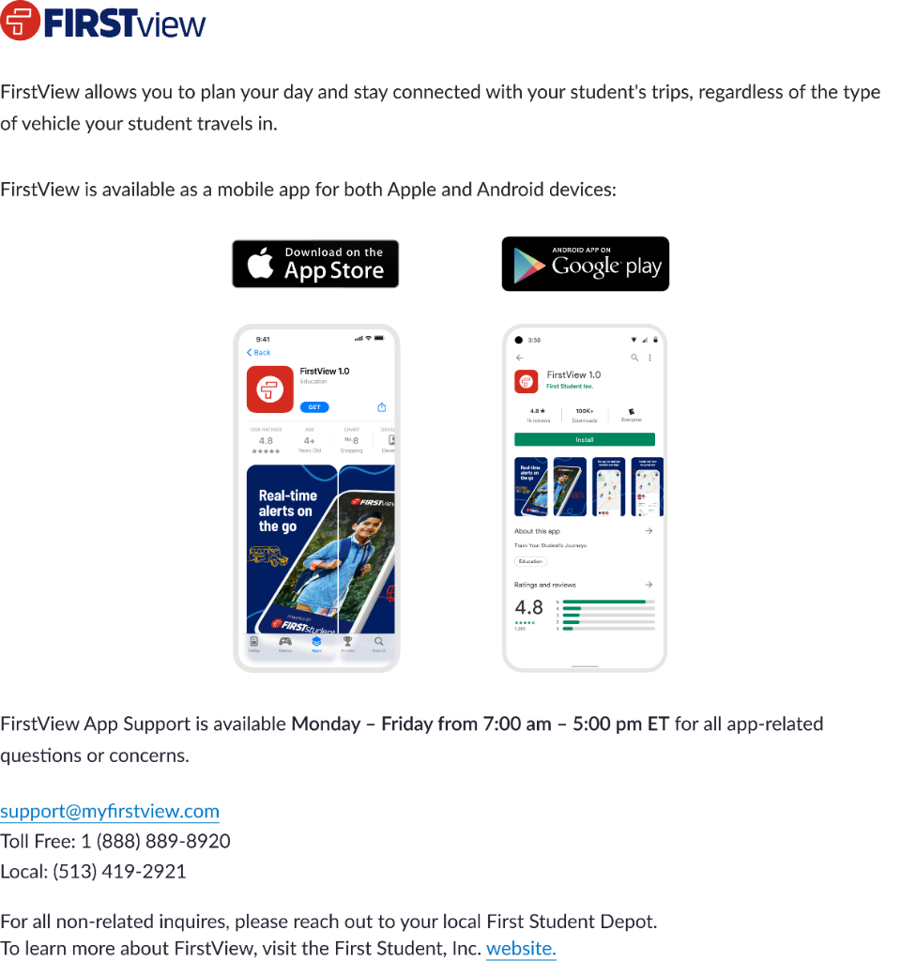](https://play.google.com/store/apps/details?id=com.firstview.foundations)[](https://apps.apple.com/us/app/firstview-1-0/id6477656451)Your student’s first and last name
* Your student’s school of attendance
* Your student’s trips to track

**Step 3:** Once you have manually added your student and their trips, set-up and receive distance notifications in app, via push notification, or via email. To set this up within the FirstView app, go to Settings > Notifications > Manage Distance Notifications.

**Step 4:** Next, you can have yourself or other family members and caregivers receive daily trip email alerts. To set this up within the FirstView app, go to Settings > Notifications > Manage Recipients.

**Step 5:** Once you have added your student(s) and signed up any additional family members and caregivers with daily trip email alerts,

begin tracking their daily trips!

|  |
| --- |
| **FirstView Customer Support is here to help mobile app users with all app-related questions:**  Monday – Friday from 7:00 am – 5:00 pm EST Parent and Caregiver Email Support: [support@myfirstview.com](mailto:support@myfirstview.com) Parent and Caregiver Phone Support: (888) 889-8920 Toll Free / (513) 419-2921 Local |