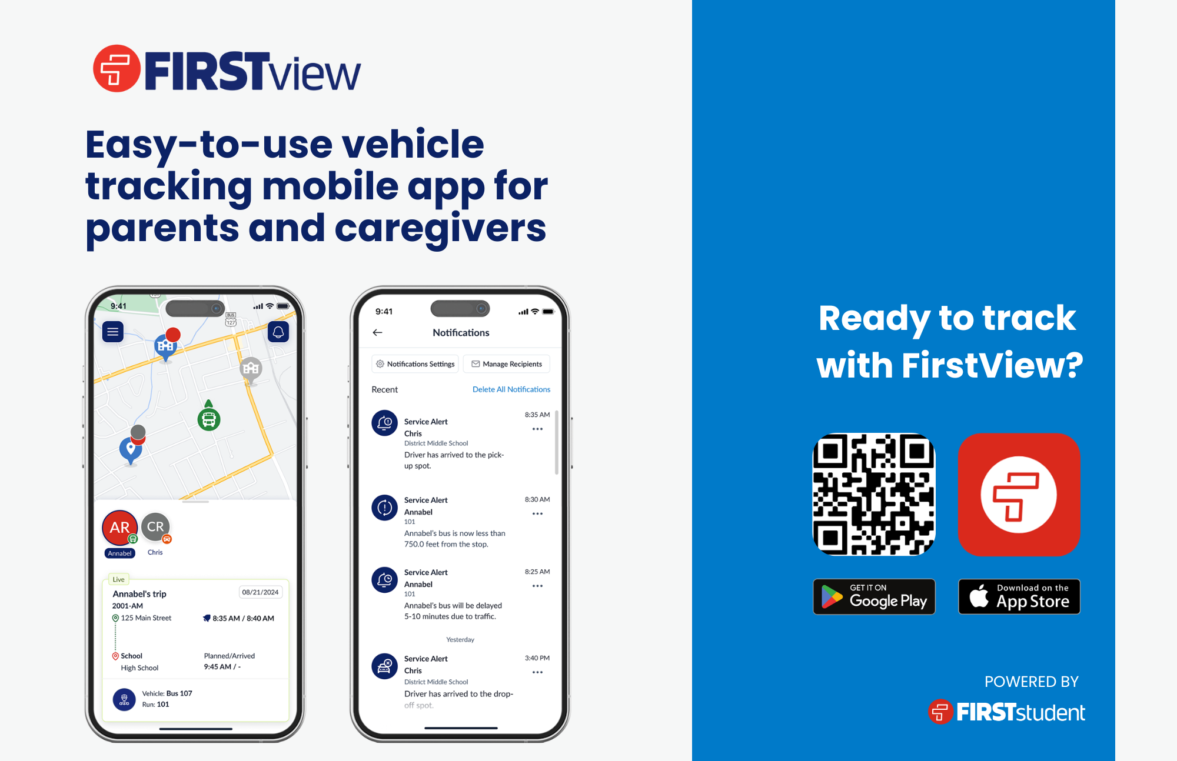
DISTRICTNAME
District Code:
12345

DISTRICTNAME
District Code:
12345

