Post 1
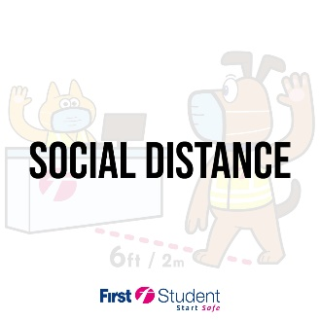 | Kids can help stop the spread of germs by keeping a safe distance from friends at the bus stop and when boarding their bus.
Post 2
 | To help keep everyone healthy, kids may not be able to sit with their friends on the bus this year.
Post 3
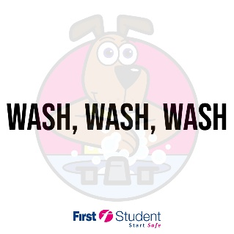 | Wash your hands often. Wash your hands for as long as it takes to sing 2 verses of Wheels on the Bus.
Post 4
 | Cover your mouth with your elbow when you cough or sneeze.
Post 5
 | Encourage your kids to tell an adult if they feel sick.
Post 6
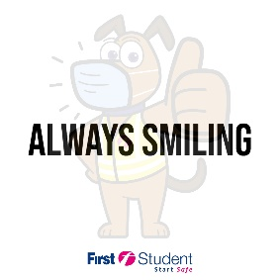 | Drivers and monitors may have a mask on, but they’re still smiling underneath!

